In your browser DevTools Network tab, trigger a request to any website
(e.g., your own site or google.com) and inspect:

URL
Method
Request headers
Response headers
Body (if any)

Write a short explanation (5–8 lines) describing what happened from request → response.

Answer:

When we send a request, in this case i have inspected the POST Request on geeksforgeeks website.

1. When my browser sent a request to gfg server i got to know about these metrics
i) 11 / 87 requests
- 87 requests → Total number of network requests the page needs
- 11 requests → Requests that are currently shown in the Network tab

ii) 7.2 kB / 452 kB transferred
- means 7.2kB of data is transferred for currently visible requests

iii) Load: 1.5 sec
- means browser took 1.5 seconds to send request, receive and loading the page.

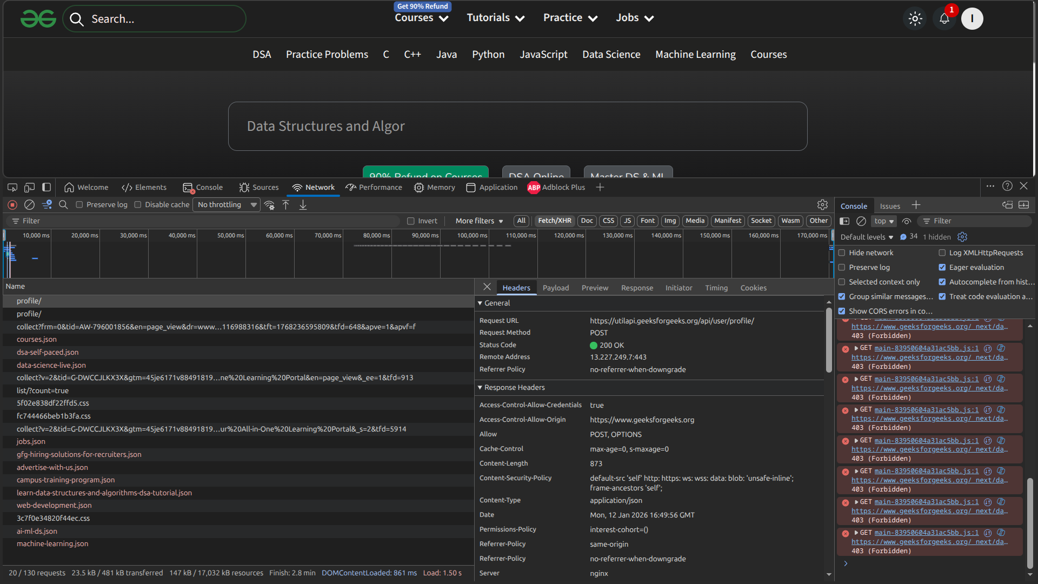

2. URl and Method
-> https://utilapi.geeksforgeeks.org/api/user/profile/
This is a url used for Post request, when i used postman to sent Post request i got the same response as the browser. Here i copied some key value pair from request header and body field from payload and used them to send the Post request.

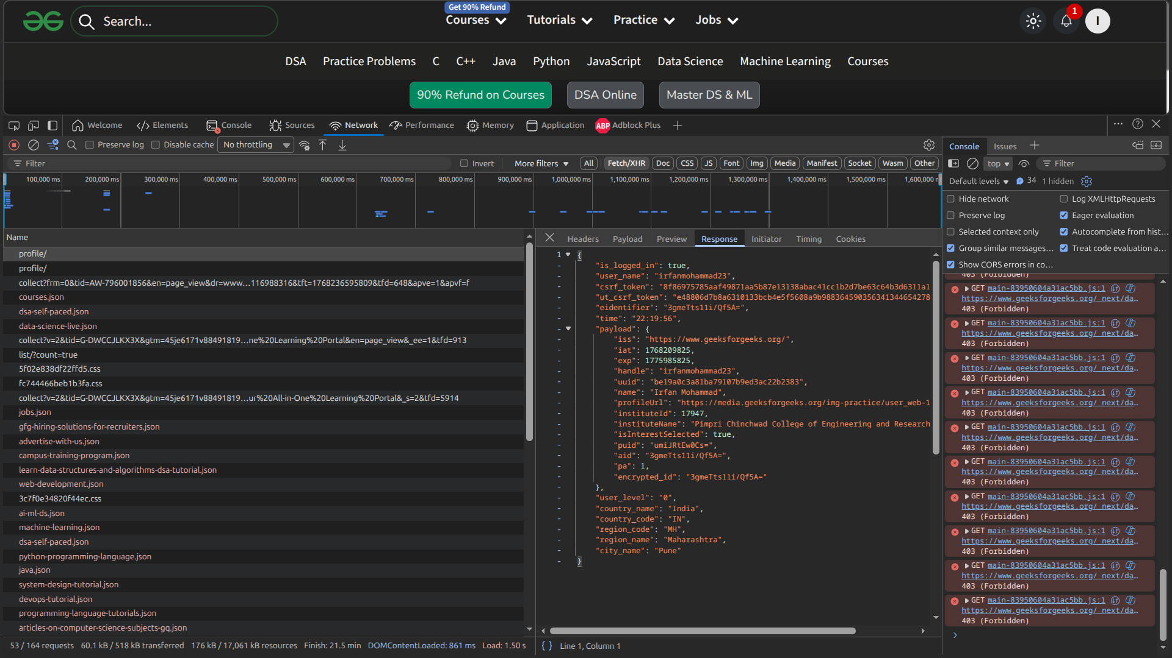
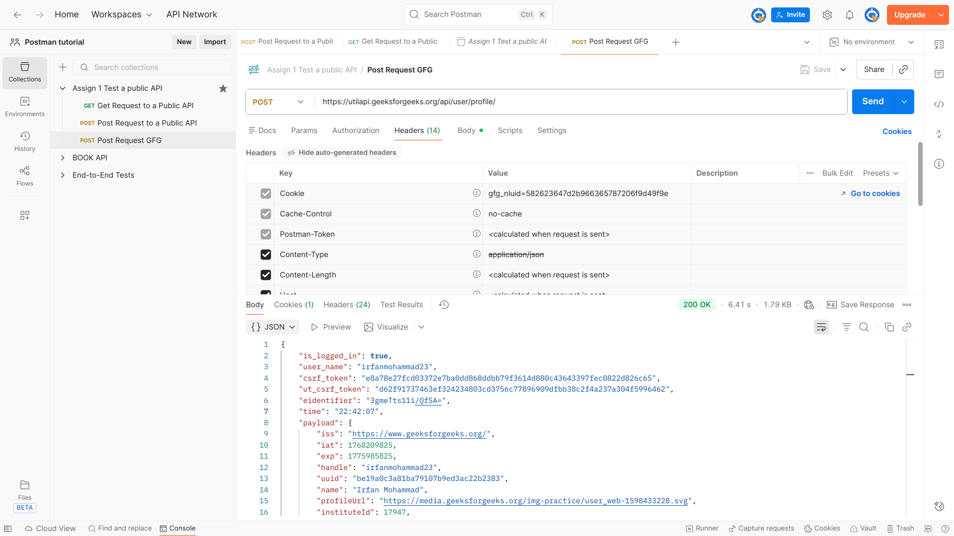

3. Request headers
- Request headers contains key-value pair which provide additional context about the request.

- Contains URL, method Get or Post

- Contains Cookie, using cookie value it is possible to send the post request using Postman and get same response.

- Content-Type : application/json, indicates that the request body is in JSON format

- Accept: */*, type of response the browser can handle.

- User-Agent, tell about the browser and operating system making the request

- Origin: https://www.geeksforgeeks.org, From where the request was initiated.

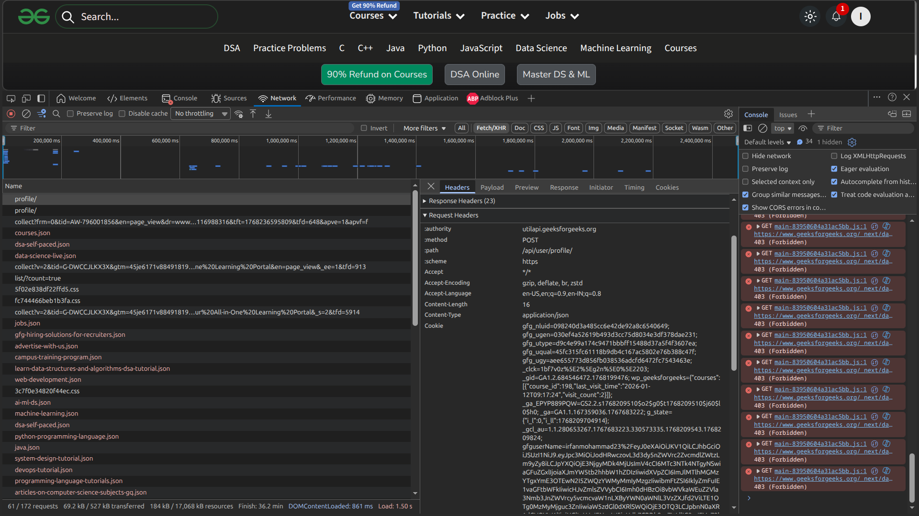

4. Response headers
- Status Code, request status.

- Content-Type: application/json, shows that the response data was returned in JSON format.

- content-length: 873, size of the response sent by the server.

- date Mon, 12 Jan 2026 17:30:30 GMT, server ka time.

- Server: nginx, tells about the web server handling the request.

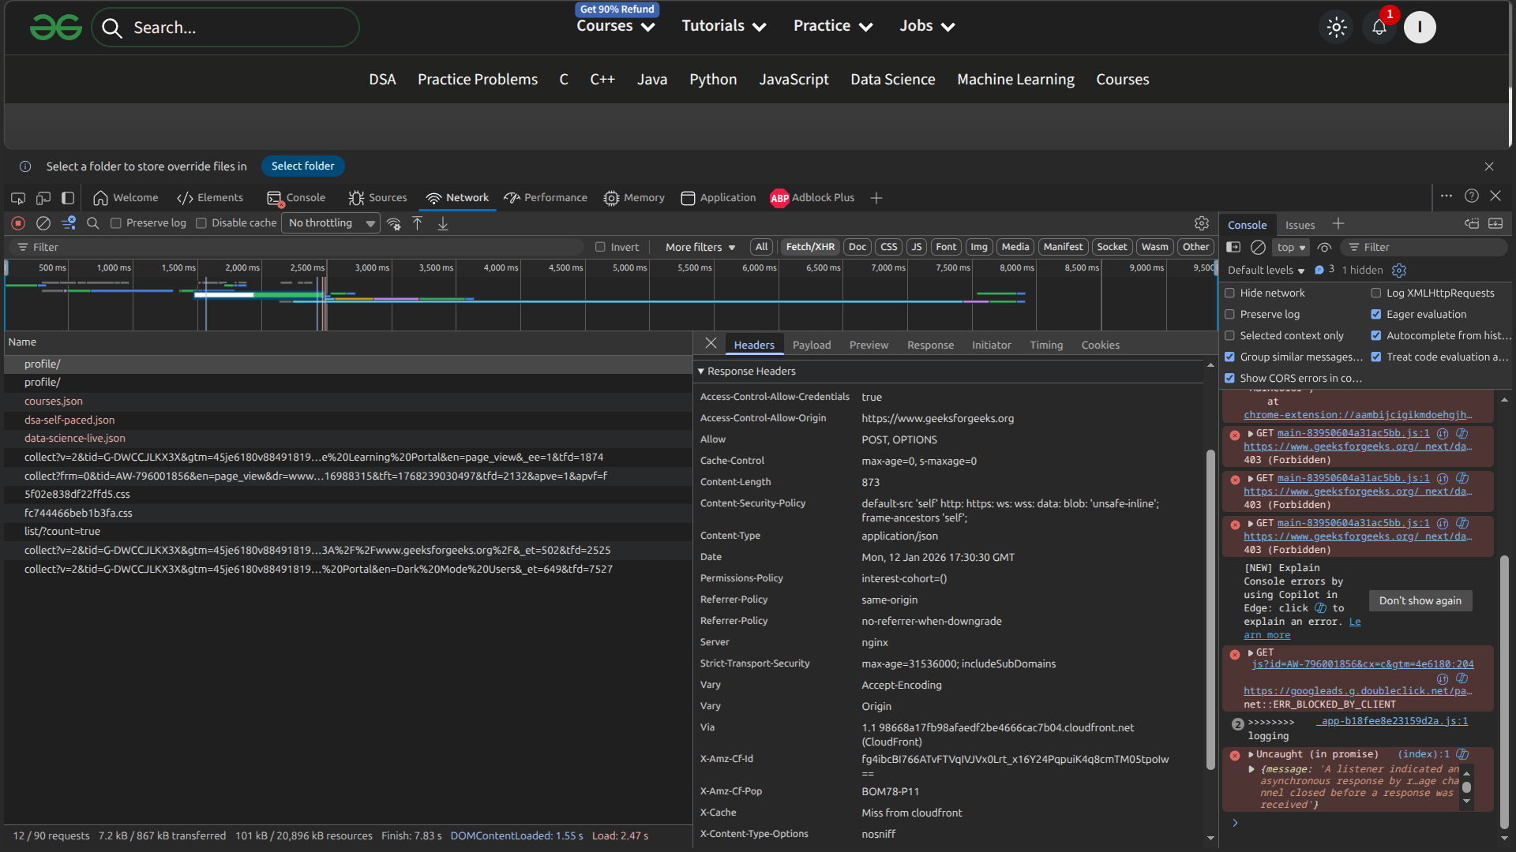

5. Request Body
- {"domain": "gfg"}, It is the request body sent in a POST request.

